|  |  |  |  |  |  |
| --- | --- | --- | --- | --- | --- |
|  |  | | | | |
|  | |  | | | |
| Project: | | Personal Health Monitoring System (PHMS)  CSE 5325 – Fall 2020  Project Management | | | |
| Module: | | COCOMO | | | |
| Deliverable: | | COCOMO Estimate Report | | | |
| Version: | | | [1.0] | Date: | [11/12/2020] |

Prepared by: Shubham Shankar, 1001761068

TABLE OF CONTENTS

1. Introduction 2

2. Estimating Factors 3

2.1 Source of Lines of Code 3

2.2 Scale Drivers 3

2.3 Cost Drivers 4

3 Project Final Timeline and Cost Structure 8

4. Conclusion and Recommendations 10

Appendices 12

# 1. Introduction

The purpose of this documentation is to estimate the cost required for the project to be completed.

The method of estimating the effort needed to build a system is cost estimation. In software engineering, cost estimation is usually concerned with the effort to construct and evaluate the software, which may also include analysis, training and purchasing of additional facilities such as servers and software specifications.

The precision of calculations is a crucial factor in choosing a cost estimation model. When too many factors are considered, cost estimates can never be accurate, and these factors can change over time.

We use Cocomo model to estimate cost of our project. Cocomo (Constructive Cost Model) is a cost estimate model for software projects. Effort & Schedule are primarily the main parameters that determine the standard of any software products that are also an outcome of the Cocomo.

Effort is the amount of labor needed for a job to be accomplished. It is measured in units of individual months. And, schedule simply means the amount of time needed to complete the task, which is of course, equal to the effort put into it. It is measured in time units, such as weeks, months, etc.

The Main difference obtained in estimation is (Previously and now) is because we have overlooked at certain parameters while using Microsoft project planner. COCOMO has considered all of these parameters.

We have previously manually calculated our costs using Microsoft tools. But COCOMO use a more procedural form of cost estimation now. COCOMO use 5 scale drivers and 17 Cost factors to make a estimation. These estimations are much more precise because COCOMO consider various factor. Previously we estimated 115.343K$ but COCOMO estimates 140K$. We can see a huge difference here. The estimation fairly says that we failed to consider certain parameters while calculating manually using project planner.

Considering the estimation provided by COCOMO there is a difference in time duration which the client offers. Client requirements are to complete the project in 3 months but our estimation says around 4.7 months. Hence, we would try convincing the client to provide more time or accept delivery in phases. As client are important for industry.

# 2. Estimating Factors

## 2.1 Source of Lines of Code

The following is the number of lines of code delivered as part of this project, A justification for the total amount of LOC is provided.

|  |  |
| --- | --- |
| **SLOC | Source Lines Of Code** | Value Chosen: 4800 |
| Justification: A project is assigned to us by the health care organization. In this project we are asked to develop a client-friendly and easy to use website and Android application program. As an application development company, we have successfully developed numerous different applications in the past and based on our experience and taking into account the specified features. Six ingredients written in HTML, Bootstrap 4, React JS, Kotlin, Android and Mongo dB, correspond to the project source file. All the features defined by the health care organization will be included in the source file, plus some extra functionality for a better user experience. The project will therefore involve around 4800 lines of code to be completed effectively. | |

## 2.2 Scale Drivers

The following is the list of scale drivers, the values applicable to this project and a justification for each value chosen:

|  |  |
| --- | --- |
| **PREC | Precendentedness** | Value Chosen: Largely Familiar |
| Justification: The project assigned does not vary much from what me and my team frequently develop. It is similar to some of our previous project. Our team also has a good organizational understanding of product and is experienced in working in related software system. | |

|  |  |
| --- | --- |
| **FLEX | Development Flexibility** | Value Chosen: Some Relaxation |
| Justification: The organization asked us to meet the minimum specifications they defined, apart from that we have been provided the flexibility of adding features that would benefit the organization and its users. | |

|  |  |
| --- | --- |
| **RESL | Architecture / Risk Resolution** | Value Chosen: Mostly (90%) |
| Justification: The project is equivalent to some of our earlier projects. We are very familiar with the architecture that needs to be used because of this and are also mindful of the risk that we will have to face while designing this project. We are also aware of the tool that are available for resolving risks. | |

.

|  |  |
| --- | --- |
| **TEAM | Team Cohesion** | Value Chosen: Largely Cooperative |
| Justification: The team is ready to accommodate any changes specified by the stakeholders, they are largely cooperative with each other and consistently synchronizes with the stakeholder. | |

**.**

|  |  |
| --- | --- |
| **PMAT | Process Maturity** | Value Chosen: SEI CMM level 4 |
| Justification: Our employees in the company are highly qualified in their area of interest and are trained if new skills are required before starting the project. | |

## 2.3 Cost Drivers

The following is the list of cost drivers, the values applicable to this project and a justification for each value chosen:

|  |  |
| --- | --- |
| **ACAP | Analyst Capability.** | Value Chosen: Very High |
| Justification: Our analysts are very effective in their field of work and have a high degree of experience. They are excellent at collecting documents, assessing business needs, and highly effective in identifying and solving business problems. | |

|  |  |
| --- | --- |
| **APEX | Applications Experience Cost Driver.** | Value Chosen: Very High |
| Justification: Our project team developing the system have a high level of applications experience. In the past, they have worked on very similar applications and have strong knowledge and experience of the design and risk they will face during the application development. | |

|  |  |
| --- | --- |
| **PCAP | COCOMO Programmer Capability Cost Driver.** | Value Chosen: Very High |
| Justification: Our team of programmers are extremely successful as a team and as individuals. They have very high ability, thoroughness and communication skills when performing an assigned task. | |

|  |  |
| --- | --- |
| **PLEX | Platform Experience Cost Driver.** | Value Chosen: Very High |
| Justification: On the provided platform, our team is efficient, they have a strong knowledge of the platform's architecture and they also understand the use of graphic user interface, database, networking, and distributed middleware capabilities. | |

|  |  |
| --- | --- |
| **LTEX | Language and Tool Experience Cost Driver.** | Value Chosen: Very High |
| Justification: The team has a high degree of programming language and software tool expertise needed for system development. They also have a strong understanding of the representation of architecture, retrieval of records, management of libraries, style of programs and formatting. | |

|  |  |
| --- | --- |
| **PCON | Personnel Continuity Cost Driver** | Value Chosen: High |
| Justification: Our organization looks after the workers well. If employees are happy, it not only improves the productivity of the company, but also increases their innovation. Our company offers plenty of facilities for employees to keep them happy and satisfied with their work. | |

|  |  |
| --- | --- |
| **TIME | Execution Time Constraint Cost Driver.** | Value Chosen: Nominal |
| Justification: Run time of web application and Android application are not to much. From fetching data from memory to making calling and iterating over functions are pretty straight forward and does not require much time to execute a program. | |

|  |  |
| --- | --- |
| **STOR | Main Storage Constraint Cost Driver.** | Value Chosen: Nominal |
| Justification: The application is created in a way that stores a large amount of data on the cloud platform. This not only increases the storage space, but also helps to improve the application's runtime, thereby making it look better. | |

|  |  |
| --- | --- |
| **PVOL | Platform Volatility Cost Driver.** | Value Chosen: Low |
| Justification: The program to be built runs on the hardware of a computer, operating system and servers. These channels have a very poor chance of receiving updates, maybe 12 months once. | |

|  |  |
| --- | --- |
| **RELY | Required Software Reliability Cost Driver.** | Value Chosen: High |
| Justification: The organization would incur a significant financial loss from a software malfunction. If people avoid using the app, it will build a bad image for our business, thereby reducing our company's customers. | |

|  |  |
| --- | --- |
| **DATA | Database Size Cost Driver.** | Value Chosen: High |
| Justification: As we are designing an app that monitors human health, it is important to test the correct functionality of the application with a reasonably large amount of data. | |

|  |  |
| --- | --- |
| **CPLX | Product Complexity Cost Driver.** | Value Chosen: High |
| Justification: The software is a bit complex. It has highly nested control processes, including a certain number of queues and stacks. Performs simple numerical operations. Software functions at the physical level, and for data fetching, basic triggers are activated. The user interface involves simple I/O and voice input as well. | |

|  |  |
| --- | --- |
| **RUSE | Required Reusability Cost Driver** | Value Chosen: Nominal |
| Justification: The components of this project are intended to be used across this project itself. Since certain functionality are specifically specified by, they may not be compatible elsewhere. | |

|  |  |
| --- | --- |
| **DOCU | COCOMO Documentation Match to Life-Cycle Needs Cost Driver** | Value Chosen: Nominal |
| Justification: At each sprint, documentation of a software development life cycle is preserved. However, each face of development is not recorded. This nominal documentation n increase software understanding as well as saves time. | |

|  |  |
| --- | --- |
| **TOOL | COCOMO Use of Software Tools Cost Driver** | Value Chosen: High |
| Justification: The development tool that my team uses allows us to write and edit efficiently, it also helps us to easily incorporate things and is considered a mature life cycle tool. | |

|  |  |
| --- | --- |
| **SITE | COCOMO Multisite Development Cost Driver** | Value Chosen: Extra High |
| Justification: Our team is a completely collocated team, interacting directly with each other, making it easy to understand details that can improve morale and help preserve the spirit of the team. | |

|  |  |
| --- | --- |
| **TOOL | COCOMO Use of Software Tools Cost Driver** | Value Chosen: Very Low |
| Justification: The assigned project does not differ much from what is often produced by me and my team. It's a similar project to some of our previous ones. So in order to accomplish the specified mission, developers do not have to make much effort. | |

# 3 Project Final Timeline and Cost Structure

* Previous Cost, Work and Duration (from assignment #2)

|  |  |
| --- | --- |
| **Item** | **Value** |
| Previous Cost (Human Resource) | $ 115,343.00 |
| Previous Cost (Non-Human Resource) | $ 15,678 (Updated as per comment) |
| Total Cost | $ 131,021 |
| 25% overhead cost | $ 32,755.25 |
| Total Price | $ 163,776.25 |
| Final price for client after 50% profit | $ 245,664.37 |
| Work | 1544 hrs. |
| Duration | 3 months |

* New Schedule (Duration)

|  |  |  |
| --- | --- | --- |
| **Totals for Entire Project** | **Duration (Mo)** | **Cost (K$)** |
| Requirements | 0.7 | 8.8 |
| Development | 4.1 | 132.1 |
| Total | 4.7 | 140.9 |

* Cost Per Person-Month

|  |  |
| --- | --- |
| **Item** | **Cost (in K$)** |
| Requirements | $ 24 |
| Product Design | $ 15.013 |
| Detailed Design | $ 21.05 |
| Code and Unit Test | $ 36.84 |
| Integration and Test | $ 18.44 |
| Maintenance | $ 2.5 |

* COCOMO Estimated Costs

|  |  |
| --- | --- |
| **Item** | **Cost (K$)** |
| **COCOMO estimated costs (Human Resources)** | $ 140.9 |
| **Non-Human Resources** | $ 15.678 |
| **Total Resource Cost** | $ 156.578 |
| **25% overhead Cost** | $ 39.1445 |
| **Total Price** | $ 195.7225 |
| **Final price for client (50% profit added)** | $ 293.58375 |
| **Duration** | 4.7 mo |

# 4. Conclusion and Recommendations

Our team has been assigned a project to design and implement a website and a corresponding android application for mobile. The project provides an easy way for the user to maintain various personal health-related data. Our team has talented brain that serve the client to fullest. The ultimate skills meet the client expectations to its best.

We're a team of six, me and five developers. Using Agile Scrum methodologies, all the project requirements will be addressed. Agile is an iterative technique whose main objective is the satisfaction of consumers. The portal and framework will be ready with a user manual for use after running several tests. Ultimately, in the end the we will deliver all the modules to the client.

The Main difference in estimation is because we have overlooked at certain parameters while using Microsoft project planner. COCOMO has taken into account all of these parameters.

Between the current and the previous study, there is a huge difference in estimate. This is because all the calculations were performed manually beforehand. Now, for us the COCOMO tool takes care of that. COCOMO is transparent. Some aspects were not considered before, such as team cohesion, Platform and Continuity of employee. COCOMO tool offers a comprehensive view of the small features that can make a big difference in our estimates. When compared to the 140K COCOMO cost estimate, our previous cost estimate was almost 115K. This tells us that some variables were overlooked, which would have caused the company significant losses in the future.

Factors are quick to incorporate, as the drivers help to estimate the effect of multiple factors affecting the projects. In COCOMO we consider 5 scale and 17 cost drivers to make a estimation. These drivers provide a much accurate prediction than what we manually calculated. These drivers consider every detail that would have been overlooked while performing manual calculation.

**Recommendation:**

After comparing the COCOMO model cost with that of the Microsoft project planner we see that there a huge difference. The cost required to complete the project according to COCOMO is 140K while we manually came up with 115K, and the duration required to complete the project according to COCOMO model is 4.7 months. We were sure that our project would be completed in 3 months. As humans we are prone to errors thus we consider the decision made by COCOMO model.

Once we get an estimation we see that the duration to complete the project is much higher that what the client expects. In this case we can “discuss the issue with the client and come up with a solution”

The possible solution could be offered:

1. We will demonstrate to the customer why 3 months is not enough to finish the project. We will try to persuade the client to allow us some extra time during this conversation.
2. In the specified period of time, we would provide the customer with either a web app or an Android application.
3. Provide customers with only significant requirements and all minor requirements can be integrated later as an upgrade.

I would try convincing the customer to retain them. I would make them understand as to why option 3 is extremely feasible and would take care of their need and also satisfy the customer.

# Appendices

**References:**

* [**https://www.geeksforgeeks.org/software-engineering-cocomo-model/#:~:text=Cocomo%20(Constructive%20Cost%20Model)%20is,%2C%20cost%2C%20time%20and%20quality**](https://www.geeksforgeeks.org/software-engineering-cocomo-model/#:~:text=Cocomo%20(Constructive%20Cost%20Model)%20is,%2C%20cost%2C%20time%20and%20quality)
* <http://www.dmi.usherb.ca/~frappier/IFT721/COCOMOII.PDF>
* <https://www.codeproject.com/Articles/9266/Software-Project-Cost-Estimates-Using-COCOMO-II-Mo>
* <https://www.geeksforgeeks.org/early-design-model-cocomo-ii/?ref=rp>
* <https://www.geeksforgeeks.org/difference-between-cocomo-1-and-cocomo-2/?ref=rp>
* <https://www.geeksforgeeks.org/software-engineering-cocomo-ii-model/?ref=rp>
* <https://www.geeksforgeeks.org/software-engineering-application-composition-estimation-model-cocomo-ii-stage-1/?ref=rp>
* <https://en.wikipedia.org/wiki/COCOMO>
* <http://www.softstarsystems.com/index.html>
* <https://www.youtube.com/watch?v=mYjzbpEUXDk&ab_channel=Master2Teach>

**COCOMO Report:**

* 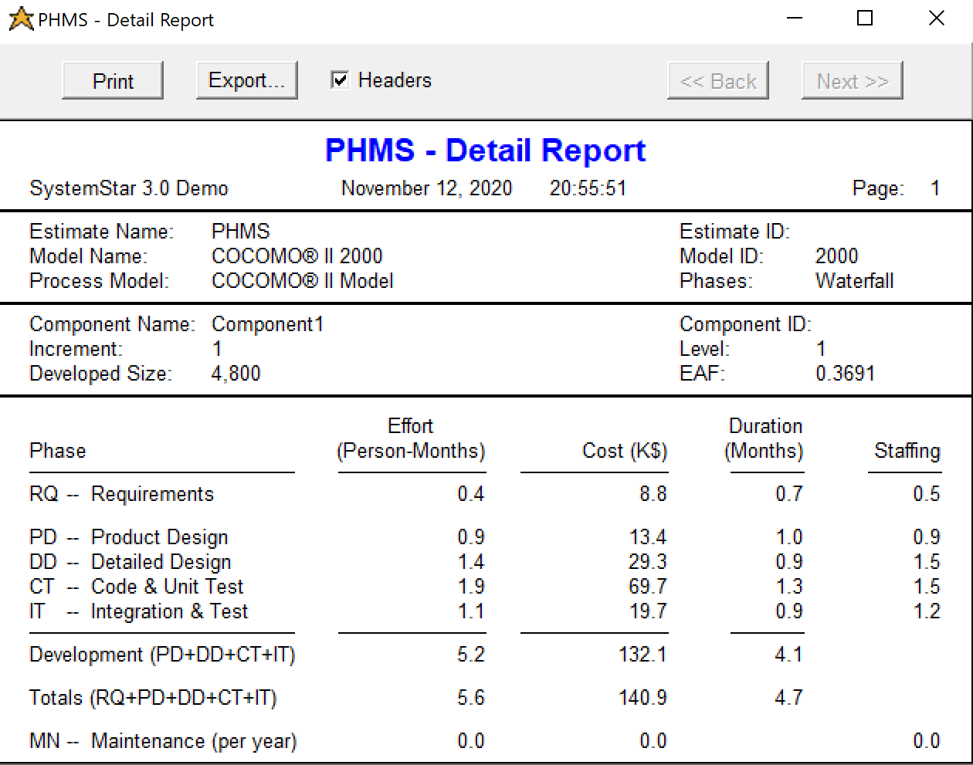**Detail Report:**
* Cost Report:

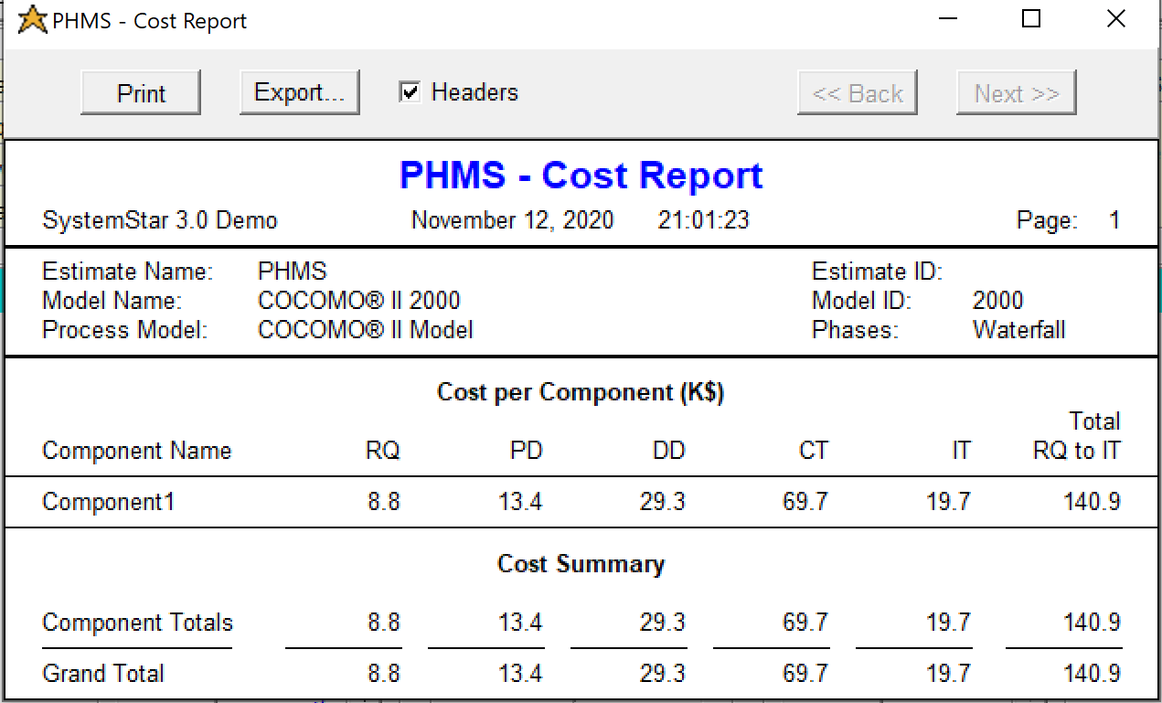

* Effort Report:
* Effort Report

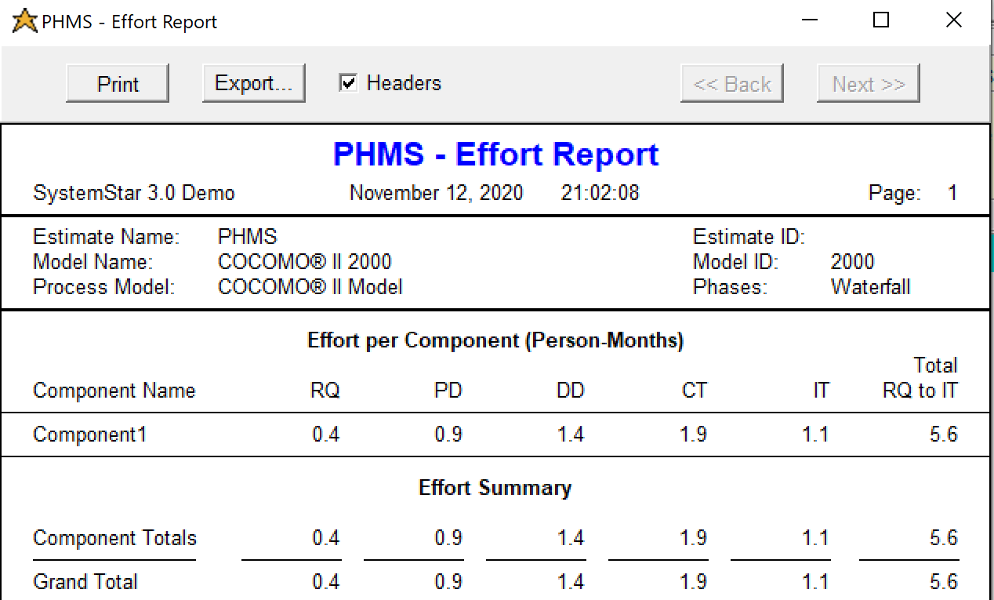

* Structure Report:

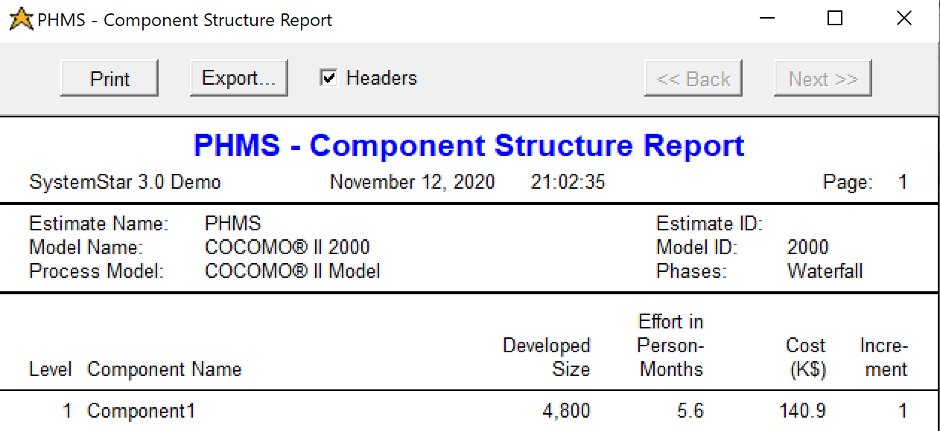

* Schedule Report:

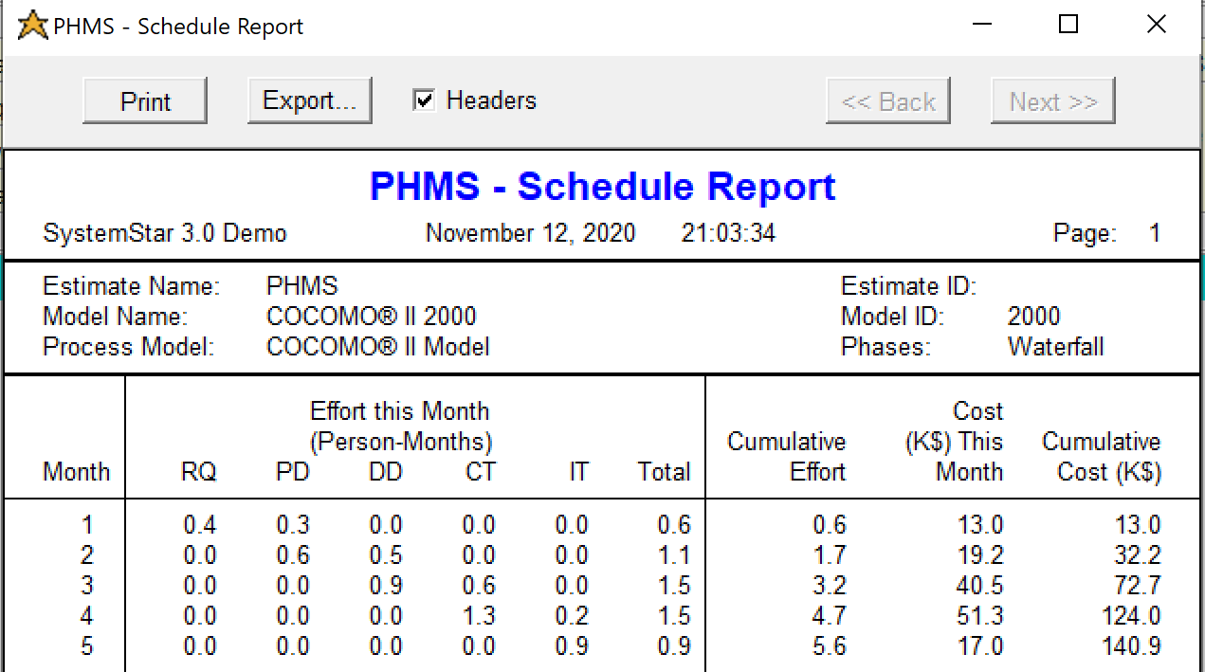

**Cocomo Tool:**

* Driver and Size

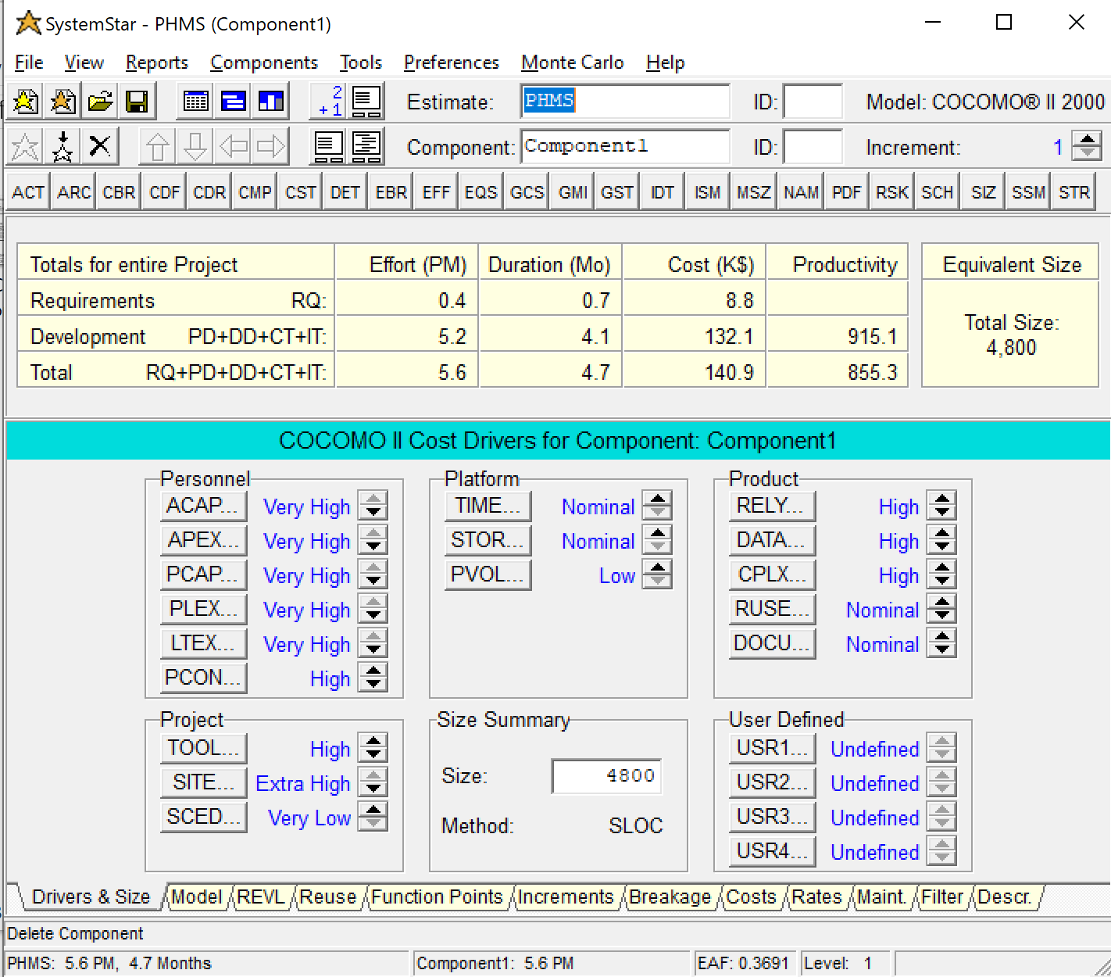

* Models:

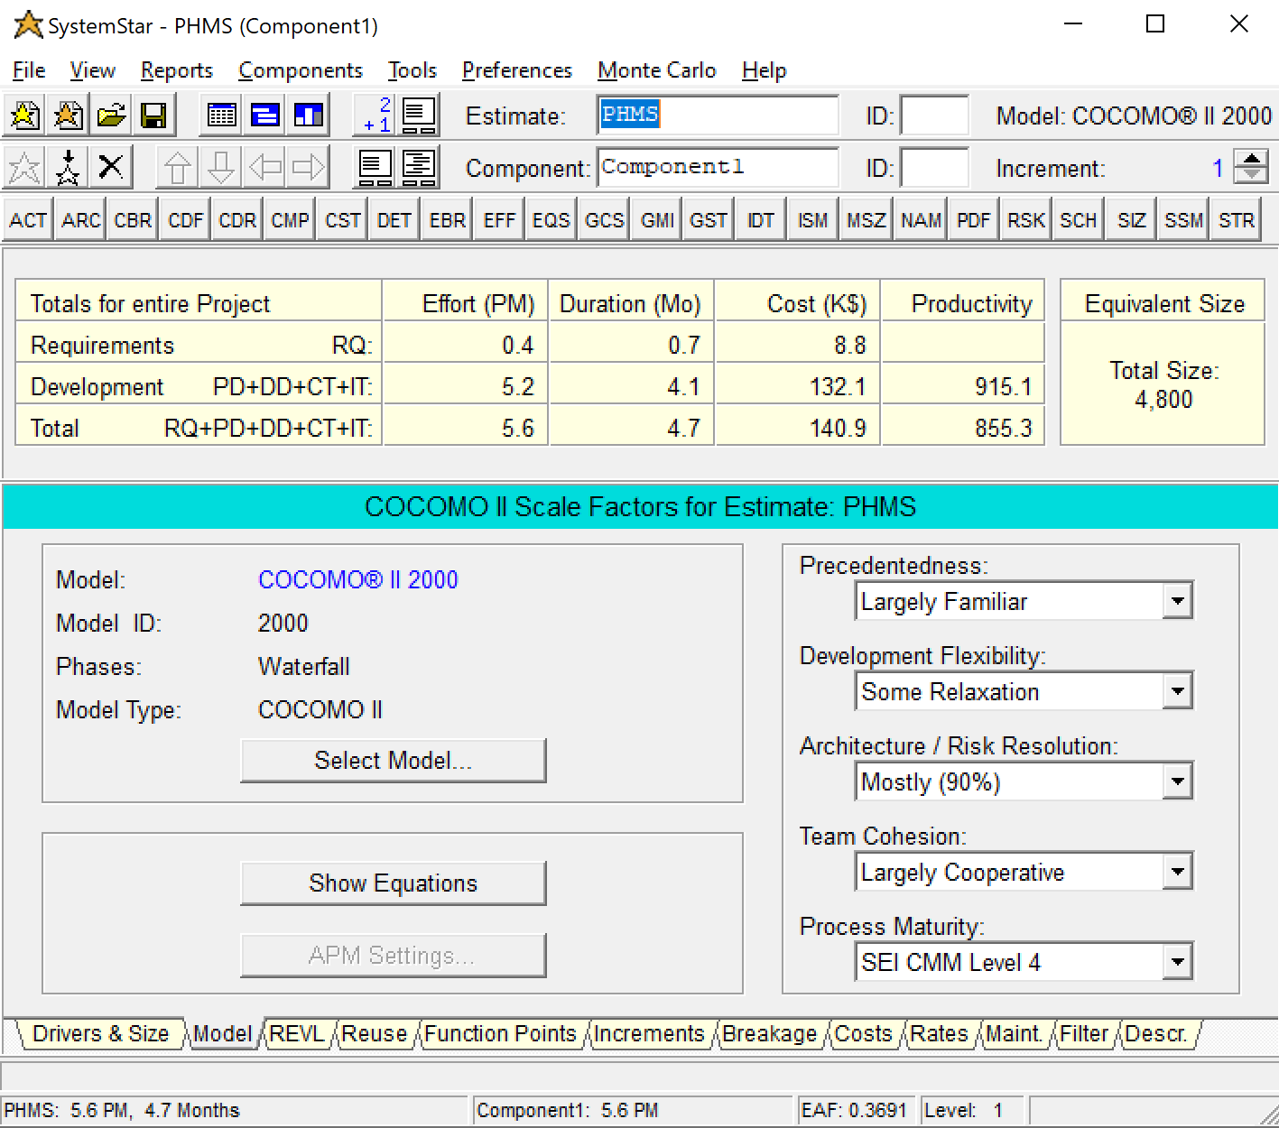

* Costs:

